ACE Live Post Deployment Workflow

Summary: This workflow will step through the process to transfer the raw data files from
the field ACE Live appliance to the Lab ACE Live appliance.

Equipment lists: 1 each Cisco roll cable- to connect to console
1 each Ethernet crossover cable (only needed if no switch available) - to
facilitate network connection to appliance.
1 each keyboard, monitor, and mouse or a laptop- to connect to
appliance console

Connecting to Appliance: There are multiple ways to connect to the appliance.
- Connect a Cisco roll cable from laptop db-9 to appliance db-9. You will need to setup a vty 100, baud 9600, 8 bits, no parity, 1 stop bit with some type of terminal emulation software i.e: hyperterm, secure crt, procomm, etc.
- You could also connect the monitor, keyboard, and mouse to the appliance.
- The third method would be to establish ip connectivity by placing your laptop on same subnet as appliance with Ethernet crossover or plug into same switch on vlan. You will need to change the laptop subnet to the same subnet as the appliance. You will need to ssh to the host address o the appliance.

- make a connection to the field appliance using one of the methods in steps 1 to 3. Login.

- Now we can start the backup of the data from the field appliance Use the browser to connect to the field appliance: x.x.x.x:8080, where x denotes the associated octets.
- Once logged in select ‘backup’ tab
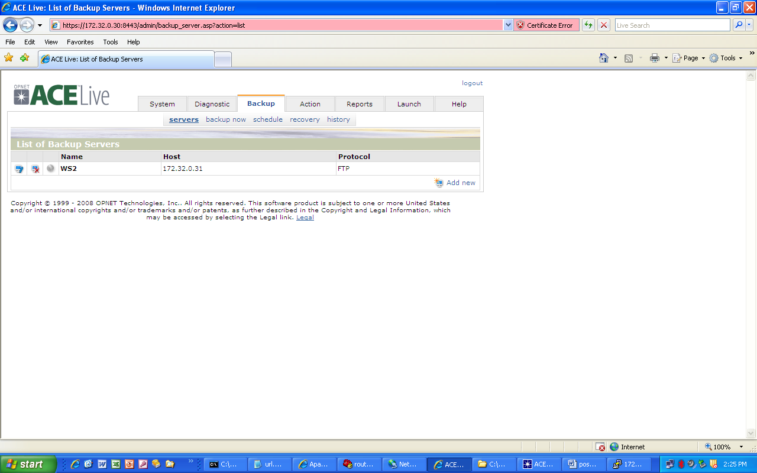

From the above menu you will add the name and ip address of the host that you will backup to and restore from.

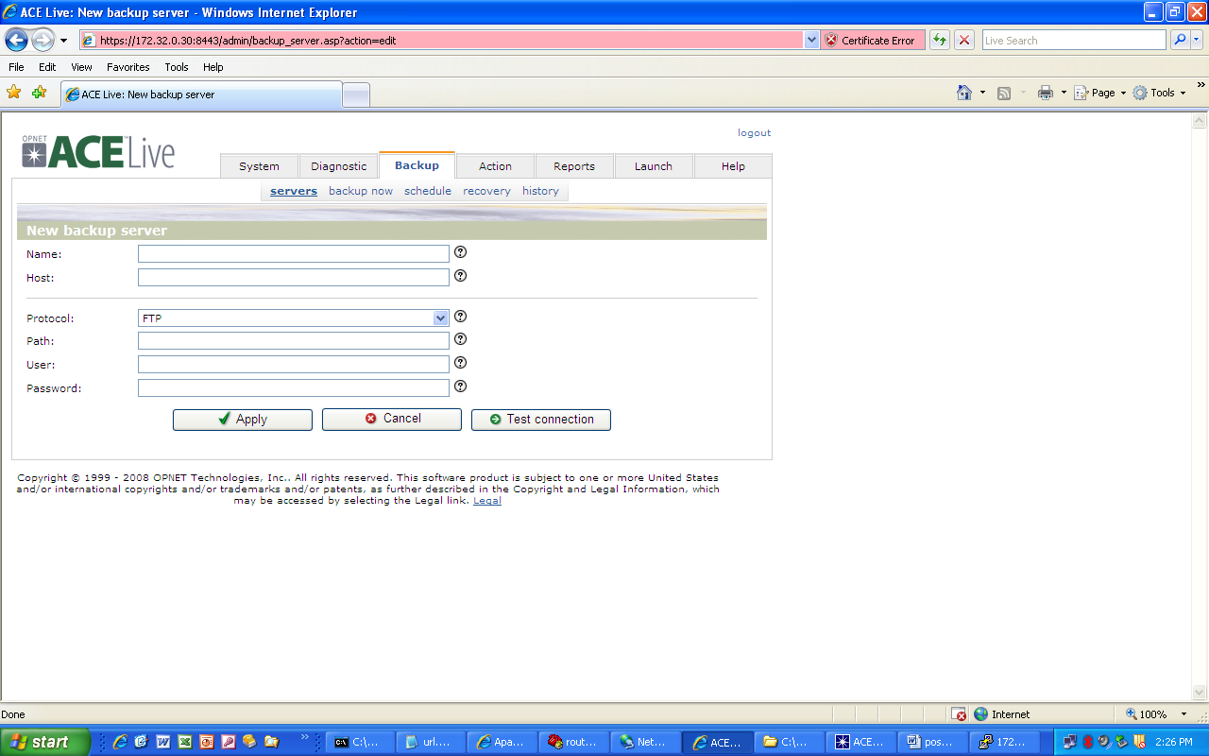

- Once you have established and tested the parameters for the host you are using for backup, you can proceed to backup.
- From the tab select ‘backup now’ and check all the boxes. This will create a backup of all the data.

- Once you have selected backup, you will see a screen like the one below:
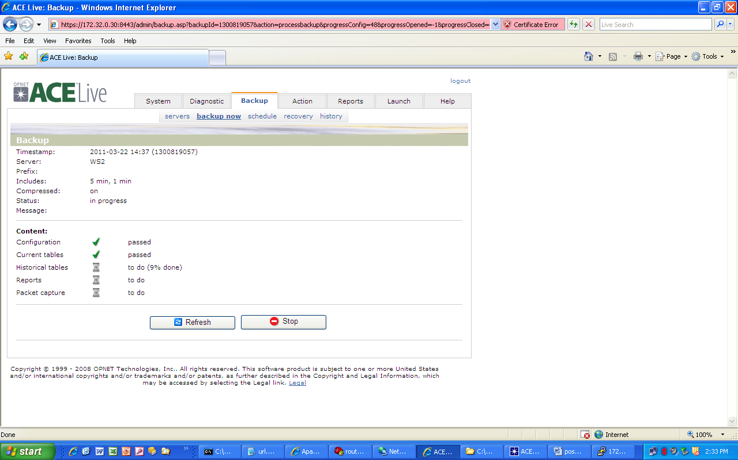

- Select the back tab
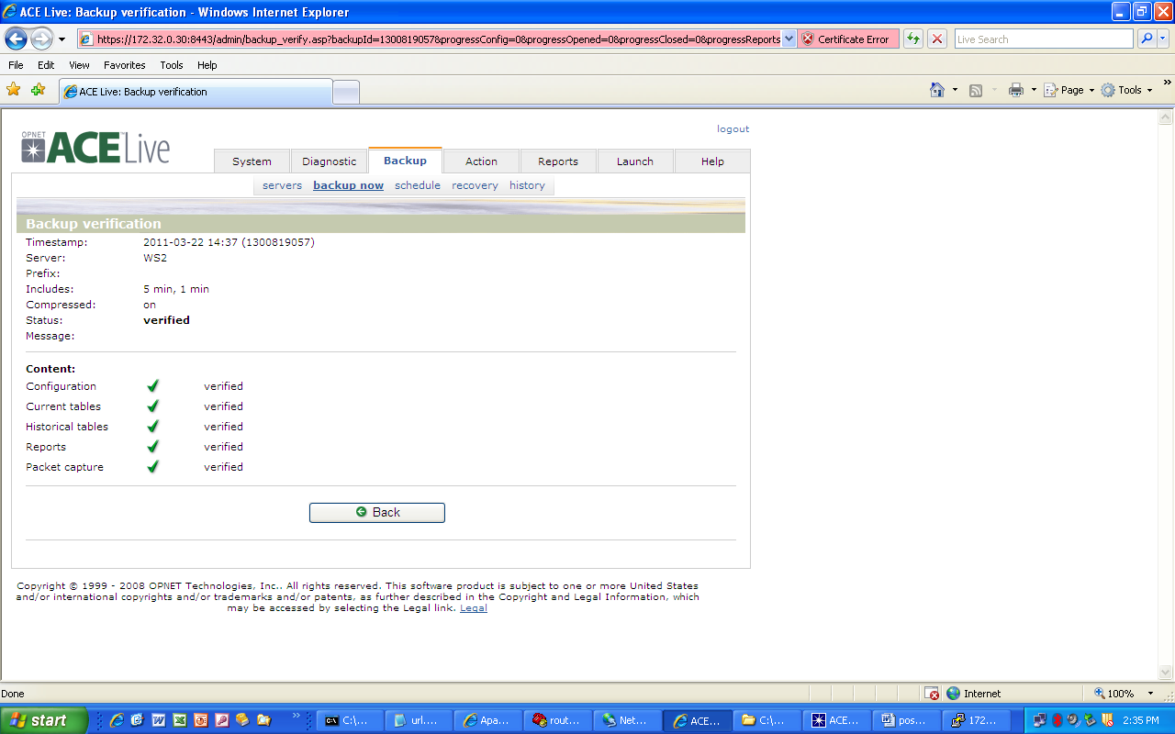

Note: You can stop here if you are only backing up the data from the field appliance. To restore data onto the lab appliance continue on.

- Now we will need to ensure that all data has been removed from the lab appliance prior to restoring data to be analyzed
- We need to rename the folder where the field appliance data was backed up to
- You need to name it so it reflects the name of the lab appliance
Note: lets say the backup appliance hostname is "eval7" and the new
appliance hostname is "stest3". Your backup folder from old
appliance will look something like the following:
eval7_6.1.1_1190847300
Before restoring this to new appliance rename the backup folder to "stest3_6.1.1_1190847300" Now the lab appliance will be able to see the folder
- Follow these quick sub-steps
- Type “CLI> rollback --noshut –keeplicense “
Note: this will clear old data off, but keep the license and not power down the appliance.
- You will need to put an ip address and device name back on the appliance.
- From the setup tab type in the correct ip and host parameters to the appliance
- Select the save tab and reboot the appliance
- Log back into the appliance
- Select the ‘backup’ tab and then select “restore”
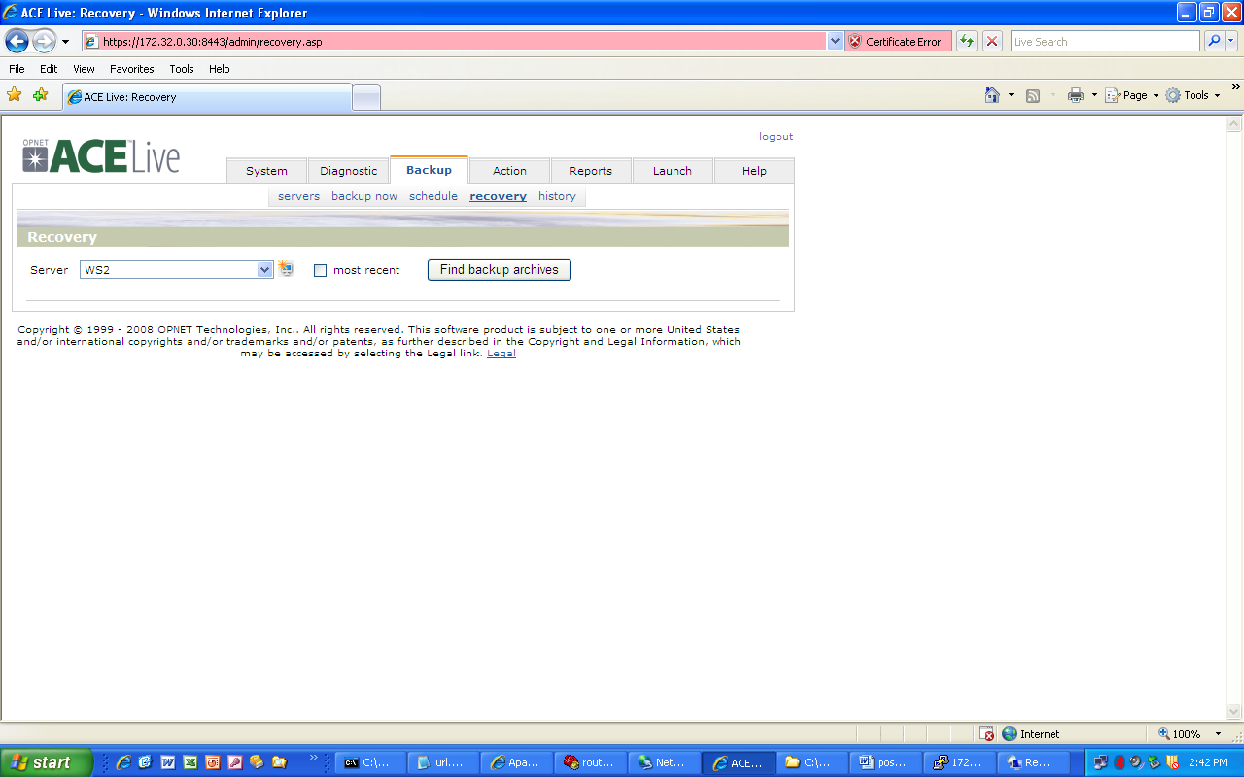

- Uncheck the most recent tab; this will enable you to see all the backup files with the lab appliances name (you changed the field appliance to). Select the one with the timestamp of the backup from the field appliance.
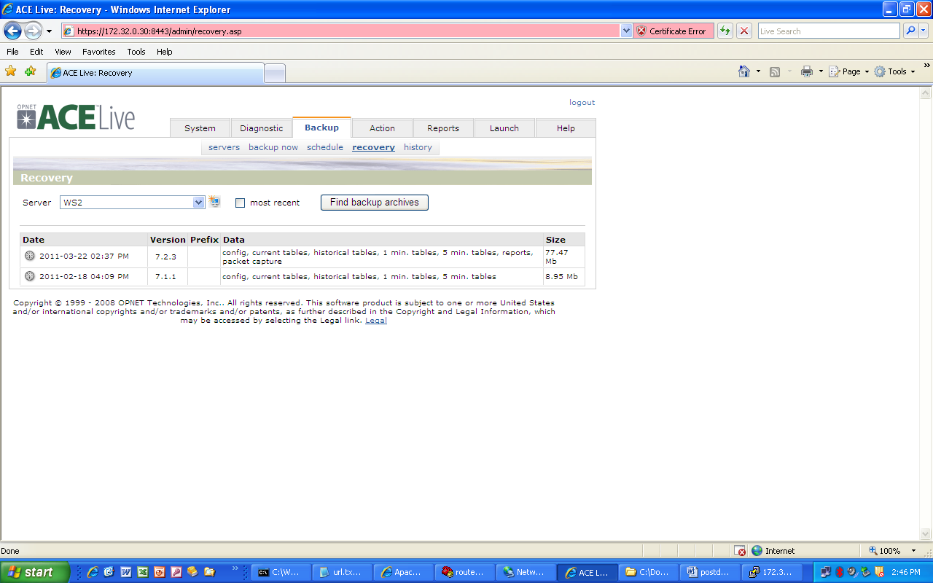
- Check all the options
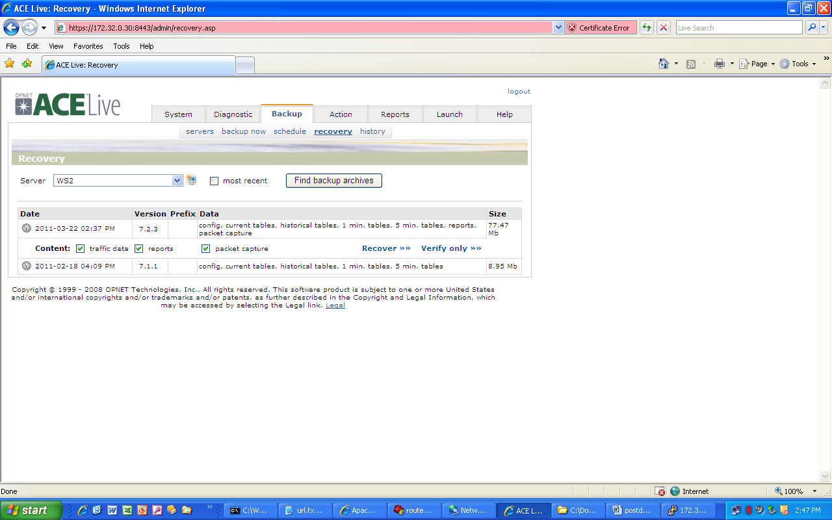

- Select ‘recover’
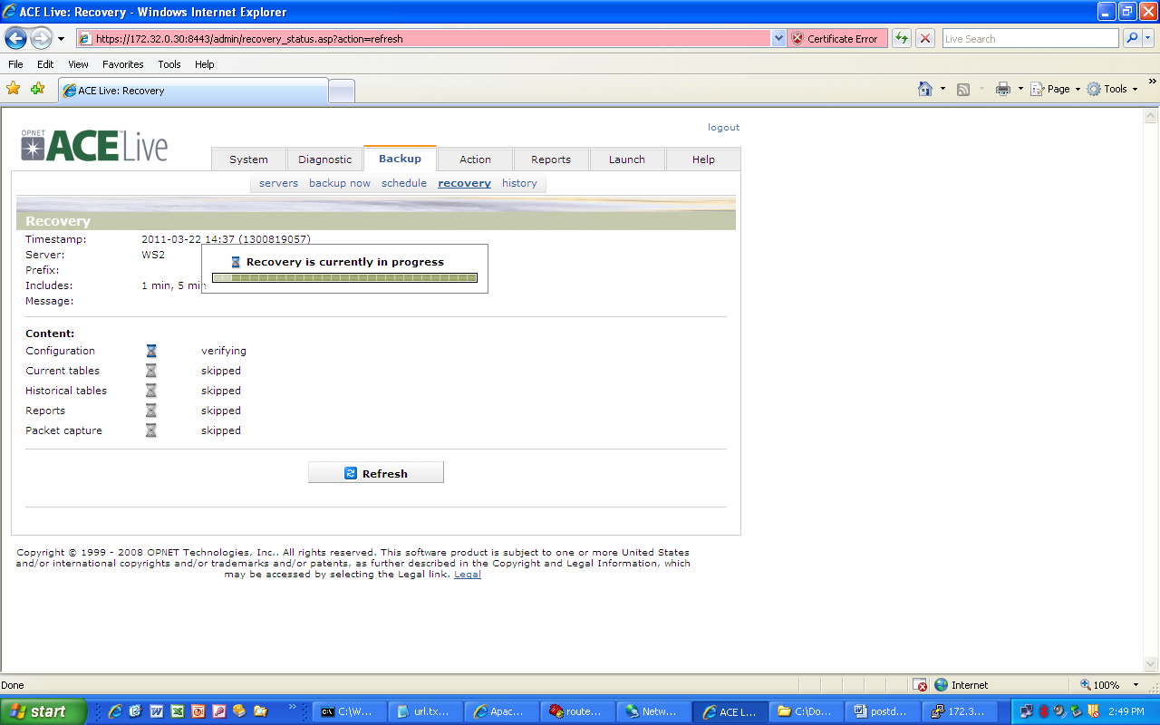

- Once again we will need to change the configuration parameters back to reflect the lab appliance’s parameters: ip address, subnet mask, host name etc.
- Once the recovery is complete it will ask you if you want to reboot the appliance. Select yes.
- Once the appliance is finished rebooting, the lab appliance is now ready to analyze the data collected from the field.

